Call for Participants

Leadership Academy for Development
“THE ROLE OF PUBLIC POLICY IN PRIVATE SECTOR
DEVELOPMENT”

Sarajevo, Bosnia and Herzegovina, July 03 - 07, 2017

Introduction

The Leadership Academy for Development (LAD) is an executive-level training program that trains government officials and business sector leaders from developing countries to help the private sector be a constructive force for economic growth and development. The program is offered in partnership with Stanford University’s Center on Democracy, Development and the Rule of Law (CDDRL), and Faculty of Political Science at the University of Sarajevo (FPN UNSA).

Instructors

Dr. Francis Fukuyama

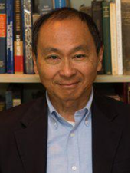
Francis Fukuyama is Olivier Nomellini Senior Fellow at the Freeman Spogli Institute for International Studies (FSI), and the Mosbacher Director of FSI's Center on Democracy, Development, and the Rule of Law. He is professor (by courtesy) of political science.

Dr. Fukuyama has written widely on issues in development and international politics. His book, The End of History and the Last Man, was published by Free Press in 1992 and has appeared in over twenty foreign editions. His most recent book, Political Order and Political Decay: From the Industrial Revolution to the Globalization of Democracy, was published in September 2014. Other books include America at the Crossroads: Democracy, Power, and the Neoconservative Legacy, Our Posthuman Future: Consequences of the Biotechnology Revolution, and Trust: The Social Virtues and the Creation of Prosperity.

Francis Fukuyama received his B.A. from Cornell University in classics, and his Ph.D. from Harvard in Political Science. He was a member of the Political Science Department of the RAND Corporation, and of the Policy Planning Staff of the US Department of State. He previously taught at the Paul H. Nitze School of Advanced International Studies (SAIS) of Johns Hopkins University and at George Mason University's School of Public Policy. He served as a member of the President's Council on Bioethics from 2001-2004.

Dr. Fukuyama is chairman of the editorial board of The American Interest, which he helped to found in 2005. He is a senior fellow at the Johns Hopkins SAIS Foreign Policy Institute, and a non-resident fellow at the Carnegie Endowment for International Peace and the Center for Global Development. He holds honorary doctorates from Connecticut College, Doane College, Doshisha University (Japan), Kansai University (Japan), Aarhus University (Denmark), and the Pardee Rand Graduate School. He is a member of the Board of Governors of the Pardee RAND Graduate School, the Board of Directors of the National Endowment for Democracy, and a member of the advisory board for the Journal of Democracy. He is also a member of the American Political Science Association, the Council on Foreign Relations, and the Pacific Council for International Affairs.

Michael Bennon

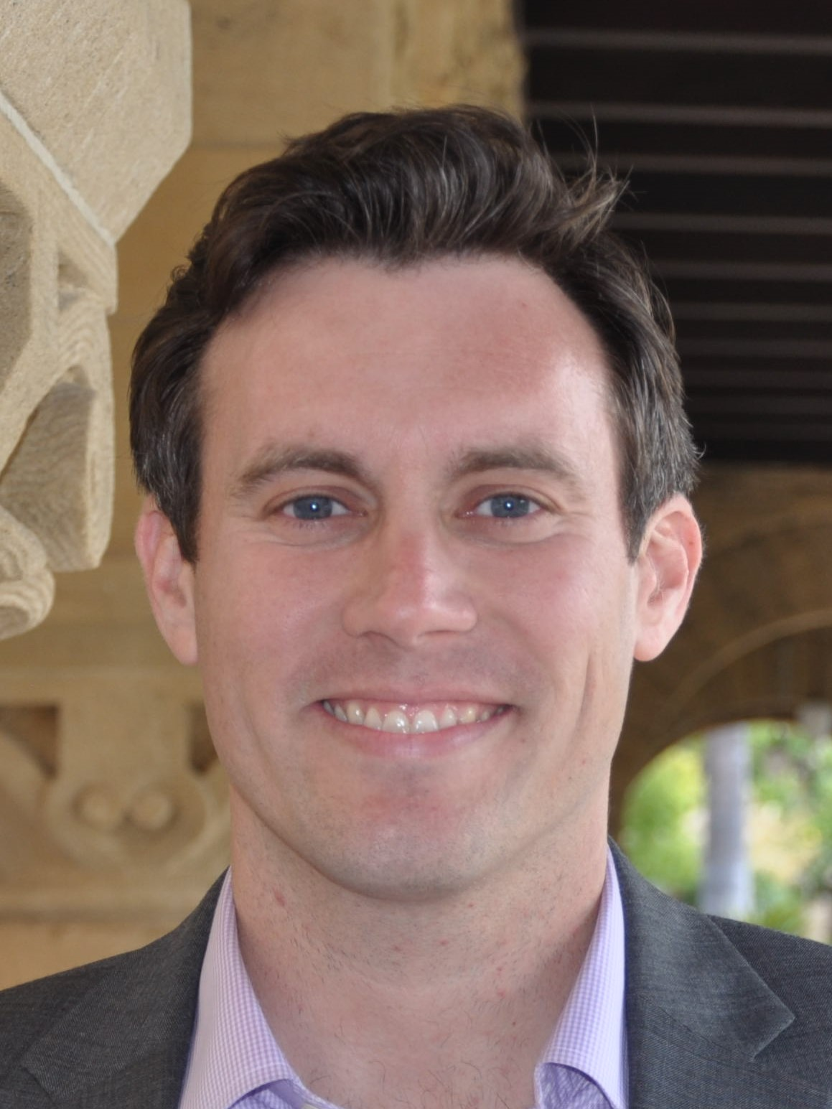
Michael Bennon is a Managing Director at the Stanford Global Projects Center, an interdisciplinary research program on innovation in infrastructure finance and development. Michael’s research focuses on Project Finance, public sector financing and management of infrastructure programs, infrastructure and real estate investment, and project organization design. Michael also teaches Global Project Finance at Stanford and is a director of the P3FLIPS program at the GPC, which works with public agencies to study best practices in the development and management of public infrastructure procurement agencies. Michael served as a Captain in the US Army and US Army Corps of Engineers for five years, leading Engineer units, managing projects, and planning for infrastructure development in the United States, Iraq, Afghanistan, and Thailand. Michael received a bachelor’s degree in Civil Engineering from the United States Military Academy at West Point and received an MSCE and MBA from Stanford University.

Overview of Program

“The Role of Public Policy in Private Sector Development” workshop is an intensive, five-day, executive-level training program that will teach selected participants how to be effective reform leaders, promoting sound public policies in complex and contentious settings. The LAD Program in Bosnia and Herzegovina will be led by CDDRL Mosbacher Director, Francis Fukuyama of Stanford University and Michael Bennon, Managing Director at the Stanford Global Projects Center.

During the program, participants will work to acquire an analytical framework necessary to promote private sector growth through public policies. Students will learn how to be successful reformers and leaders by analyzing stakeholders, sequencing actions, managing conflicts and building coalitions. In order to do so, policymakers must have a solid grasp of country - specific economic, financial, political and cultural realities.

This is a largely case-based curriculum featuring key lectures that provide the necessary conceptual framework. The “case method” is a technique of teaching and learning through the analysis of actual events that have occurred, allowing you to gain a realistic understanding of the roles, responsibilities and analytical skills required of decision makers, as well as the tensions that may arise between various stakeholders with different objectives. Participants are encouraged to draw from their own experiences to enrich classroom discussions and stimulate debate.

Participant Selection

All interested candidates should fill out the following application:

https://goo.gl/lmCPoV by May 29, 2016.

You will receive a confirmation of receipt within 24 hours following the submission of the application. If you do not receive a confirmation email, please contact us immediately by phone +38761245257 or by email addresses ladbalkans2017@fpn.unsa.ba.

Finalists may be required to participate in a short phone or Skype interview. The interview will be scheduled during the week of May 29 - June 04 and participants will be notified of their selection by June 8.

Participants will be selected based on the following criteria:

- experience in the field of political science, economics, social science, or international economic relations;
- applicants should be mid-career practitioners, with at least five years or more of working experience;
- in their present capacity, applicants should play important and influential roles in their country’s political, economic, and social development. Applicants can be working as policy-makers, business sector leaders/entrepreneurs, academics and leaders of civil society organizations (such as representatives of trade unions, nongovernmental organizations, the media, business and professional associations);
- good command of English
- strong analytical skills
- ability to work in teams.

Dates of Program: July 2 - July 8, 2017.

Venue: Faculty of Political Science at the University of Sarajevo, Skenderija 72, Sarajevo, Bosnia and Herzegovina

Language of Instruction: English.

Participant Cost: The cost for participation in the program will be 200 EUR. Costs of travel, accommodation and meals throughout the program will be covered by the organizers.

Certification: Each participant will recieve a certificate that would indicate that he/she had completed the following short course: The Role of Public Policy in Private Sector Development, presented by the Faculty of Political Science of the University of Sarajevo in the partnership with the Leadership Academy for Development

Contact:
Sead Turčalo
Email: sead.turcalo@fpn.unsa.ba
Tel: +38761245257

Darko Brkan
Email: darko.brkan@gmail.com
+38761205546

