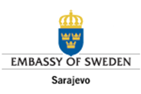

PUBLIC ADMINISTRATION REFORM MONITORING IN BOSNIA AND HERZEGOVINA: ANALYSIS OF RESULTS IN THE AREA OF PUBLIC FINANCE
2015

This document has been prepared under the Public Administration Reform Monitoring (PARM) project, implemented by TI BiH and CIN, with financial support from the Swedish International Development Agency (SIDA) and the Government of Denmark. The views and opinions expressed herein are solely those of TI BiH and can in no way be taken to reflect the views of SIDA or the Government of Denmark.

March 2016
Acronyms and abbreviations
BiH | Bosnia and Herzegovina
BD | Brčko District
FBiH | Federation of Bosnia and Herzegovina
RS | Republika Srpska
GOF | Global Framework of the Fiscal Balance and Policy
IMF | International Monetary Fund
BFP | Budget Framework Paper
DEP | Directorate for Economic Planning
IAS | International Accounting Standards
ITA | Indirect Taxation Authority
MAU | Macroeconomic Analysis Unit of the ITA Governing Board
ERP | Economic Reform Programme
MFT | Ministry of Finance and Treasury
MF | Ministry of Finance
IPSAS | International Public Sector Accounting Standards
GFS | Government Finance Statistics
PARCO | Public Administration Reform Coordinator’s Office
SBA | Stand-by Arrangement
ESA | European System of National and Regional Accounts

Table of Contents
I INTRODUCTION 6
II Findings of the public finance reform monitoring in BiH 7
1. Policy dimension of the public finance system 8
2. Increasing efficiency and effectiveness of budget management 11
2.1 Transparent expenditure of public funds 12
2.2 Communication between management of institutions and finance units 14
2.3 Introduction of programme-based budgeting in public administration in BiH 14
2.4 Including parliaments in the budget approval process 15
2.5 Inclusion of extra-budgetary funds in the medium-term expenditure framework and budget process 16
3. Improving the accounting framework and the treasury system operations 17
4. Introduction of PIFC in full compliance with EU requirements 18
5. Improving the organisational structure and investing in capacity-building 19
6. Improvement of public debt management efficiency 20
III Recommendations for achieving PAR objectives in the area of public finance 23
IV Annexes 29
Annex 1 29
Annex 2 30

I INTRODUCTION

This report on results of the public finance reform in BiH in 2015 is the second monitoring report under the Public Administration Reform Monitoring Project in BiH (PARM).
This report is the result of monitoring the reform established under the Revised Action Plan 1 (RAP1), which is an integral part of the Public Administration Reform Strategy in BiH, adopted in 2011.
Activities to achieve the objectives defined under RAP1 include eight chapters: policy dimension of the public finance system; increasing efficiency and effectiveness of budget management; improving the accounting framework and the treasury system operations; introduction of PIFC in full compliance with EU requirements; improving the organisational structure and investing in capacity-building; public-private partnership development; public procurement system; and improvement of public debt management efficiency.
The report does not include two chapters, namely on public-private partnership development and on public procurement system, because the institutions that are in charge of implementation of these objectives were not subject to monitoring.
The report was prepared on the basis of: review of existing primary sources of information, including relevant laws, administrative procedures, financial and other information on the performance of all governments in BiH; collection of additional information through questionnaires that were distributed to 46 institutions included in this monitoring survey; and the collected opinions and consultations at the round table held on 9 March 2016.
Monitoring of results achieved in the area of public finance in public administration for 2015 includes 46 public institutions at the state and entity levels and in Brčko District. The sample envisaged monitoring of 15 institutions each from the state and entity levels, as well as institutions of Brčko District.
Of the 46 institutions included in the sample, some refused to fulfil their legal obligation to disclose information of public importance and thus contribute to the monitoring. These institutions are not sensitised to the need for providing the general public with comprehensive presentation of the results of their work:
- at the level of BiH: Ministry of Foreign Affairs of BiH and Ministry of Justice of BiH,
- at the level of FBiH: Ministry of Education of FBiH, Ministry of Displaced Persons and Refugees of FBiH, Ministry of Health of FBiH, Banking Agency of FBiH and Agency for Privatisation in FBiH.
- at the level of RS: Ministry of Public Administration and Local Self-government, Ministry of Finance, Ministry of Agriculture, Forestry and Water Management, Ministry of Family, Youth and Sports and Banking Agency of RS.
- None of the institutions from Brčko District submitted information.

Institutions that provided information, but after the given deadline:
- Ministry of Defence of BiH,
- Ministry of Finance and Treasury of BiH, and
- Ministry for Refugees and Displaced Persons of RS.

The response rate and the quality of the submitted data was in line with expectations.

II Findings of the public finance reform monitoring in BiH

Reform Agenda for Bosnia and Herzegovina for the period 2015-2018, adopted by the Council of Ministers of BiH, the Government of FBiH, the Government of RS, the cantonal governments and the Government of Brčko District, recognises the need for concrete action to be taken to ensure fiscal and financial sustainability and undertake socio-economic reforms.
Improving public financial management is one of the priorities of the structural reform in BiH, with special emphasis on enforcing fiscal discipline and improving the internal financial control system.
The analysis of individual activities undertaken with the aim of achieving the set objectives has shown that, since 2014, FBiH has made significant progress in the public finance reform compared to other levels of government.

Figure 1. Implementation of ​​public finance reform as at 31 December 2015
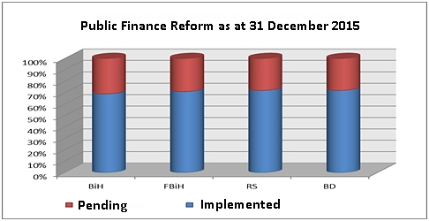
Source: Monitoring findings

1. Policy dimension of the public finance system

This section discusses activities aimed at improving the quality of the development of the macro-fiscal framework for whole BiH, as well as those undertaken for the purpose of ensuring regular preparation of the consolidated public sector account and instituting a more efficient distribution of revenues from indirect taxes (defining the formula for vertical distribution).
The Law on Fiscal Council in BiH (“Official Gazette of BiH”, No. 63/08) defines the Global Framework of the Fiscal Balance and Policy in BiH (GOF) as a document containing the following parameters: the proposed fiscal objectives of the budget of the institutions of BiH, FBiH, RS and BD; the proposed macroeconomic projections and the projections of the total indirect taxes and their distribution for the next fiscal year; and the proposed borrowing ceilings of the budgets of the institutions of BiH, FBiH, RS and BD. Pursuant to the provisions of this Law, the GOF is adopted in the form of an agreement between the Government of FBiH, the Government of RS and the Council of Ministers of BiH and is issued for the following three years and is reviewed every year. The Fiscal Council Advisory Group of BiH prepares the proposed basic or revised GOF document and submits it to the Fiscal Council no later than 15 May every year.
The Fiscal Council was late in adopting the Global Framework of the Fiscal Balance and Policy in BiH (GOF) in 2014 and has continued the practice of delayed adoption, adopting the 2016-2018 GOF as late as 23 June 2015.
The 2016-2018 GOF: set fiscal objectives defined as a primary fiscal balance; established macroeconomic indicators and projections for the 2016-2018 period; made projections of total revenues from indirect taxes and their distribution for the 2016-2018 period, and set the borrowing ceiling only for 2016.
The 2016-2018 GOF was prepared drawing on macroeconomic indicators and projections prepared by the Directorate for Economic Planning of BiH (DEP), the structure of indirect tax revenue and projections prepared by the Macroeconomic Analysis Unit of the ITA Governing Board (MAU), and the data of all three ministries of finance and the Finance Directorate of BD.
The first and second chapters of GOF: analysis and trends of macroeconomic developments in BiH and analysis of the level and structure of indirect taxes and their projections were prepared and explained in detail for the reference period.
Unlike the first two chapters, the definition of fiscal objectives and fiscal policy of BiH as well as the section that refers to the level and structure of public spending are presented very scantly, merely by way of budget framework tables submitted by each government level. The determined level and structure of public spending for BiH in the 2016-2018 period is the result of the sum of data of total budget frameworks prepared by the institutions of BiH, BD, FBiH and RS. It should be noted that in the 2016-2018 GOF budget frameworks for individual government levels were prepared on the basis of data which are not comparable; for example, unlike RS, FBiH did not include ESCROW funds, budget beneficiaries that have their own accounts, as well as foreign projects that are not part of the treasury system operations.
Since as early as 2011, this section of the document has stated that the level of public expenditure as a share of GDP should be below 40% of GDP. One gets the impression that the only thing that changes in the GOF documents adopted so far is the years “X” and “Y” in the following sentence: “The level of public expenditure as a share of GDP in the X-Y period should be continuously reduced with the aim of ensuring that the level of public expenditure as of year X, consolidated at the countrywide level, is below 40% of GDP”. This objective of reducing the level of public expenditure is not supported by any analysis and there is no explanation of the measures with which to achieve it.
Borrowing ceilings were not analysed and no projections for the three-year period were prepared, and GOF does not give a complete picture of the borrowing ceiling at the level of BiH. This section of the GOF contains a list of regulations that regulate borrowing, debt and guarantees at the level of BiH, FBiH and RS. Borrowing ceilings for entities were set only for the year 2016 on the basis of information submitted by each government level.
In practice, the Fiscal Council of BiH adopts only projections of indirect tax revenues, which are the basis for the planning and preparation of BFPs for all levels of government in BiH, as well as decides on the budget of the Institutions of BiH.
Delays in the adoption of GOF directly affect adoption of the Budget Framework Papers (BFPs) for the government levels in BiH by June 30, as defined by the budget calendars, the Law on Financing the Institutions of BiH, the Law on Budgets in FBiH, and the Law on Budget System of RS. In order to ensure regular preparation of the comprehensive macro-fiscal framework for BiH, it is necessary for the competent institutions to submit all necessary information in accordance with the deadlines for the drafting GOF so that it can be prepared and submitted by 15 May. Also, the existing GOF format should be extended to contain, in addition to projections of indirect taxes, more detailed tables and data on such items as revenues, expenditures, financing and fiscal objectives for both BiH and for each individual level of government. The timely adoption of GOF creates preconditions for timely adoption of BFPs based on data from the Global Framework, which was not the case in previous years.
The Central Bank of BiH (CBBH) prepares, on a quarterly and annual basis, consolidated report on government operations. The CBBH has the obligation to publish the consolidated report on government operations by 30 June of the current year for the previous year and the CBBH complies with this obligation.
By its decision adopted on 1 April 2010, the Fiscal Council made it mandatory for the Macroeconomic Analysis Unit of the ITA Governing Board to prepare consolidated data for the central and general government of BiH using the format prepared by the IMF, with the aim of monitoring Stand-by Arrangements (SBAs). Since 2010 all reports have been published on the website of MAU. Reports for the third and fourth quarter of 2015 were prepared with a delay because, otherwise, they would not be comparable with the previous ones as RS did not submit its reports on time.
Consolidated report prepared by MAU for the purpose of reporting to IMF and monitoring SBAs includes some public enterprises/directorate unlike the consolidated reports of the CBBH. MAU consolidates its report from the following reports: on revenues and expenditures of the budget of the Institutions of BiH; on revenues and expenditure of the budgets of FBiH, cantons, cantonal roads directorates, local governments and public funds in FBiH; revenues and expenditures of the budget of RS, public enterprise RS Roads, public enterprise RS Highways, local governments and public funds in RS (including extra-budgetary funds recorded in the General Ledger of the Treasury of the Republika Srpska, total foreign debt for the projects implemented through local governments and enterprises, as well as data on RS budget beneficiaries that have their own bank accounts (including the units for implementation of foreign projects established within ministries); and revenues and expenditures of the budget of BD and public funds in BD. Better cooperation and information exchange among different levels of government is an essential prerequisite to enabling the regular production of the consolidated public sector account, and the aforementioned delays in the delivery of data for consolidation should be eliminated.

Graph 1. Quarterly reporting for the purposes of SBAs monitoring
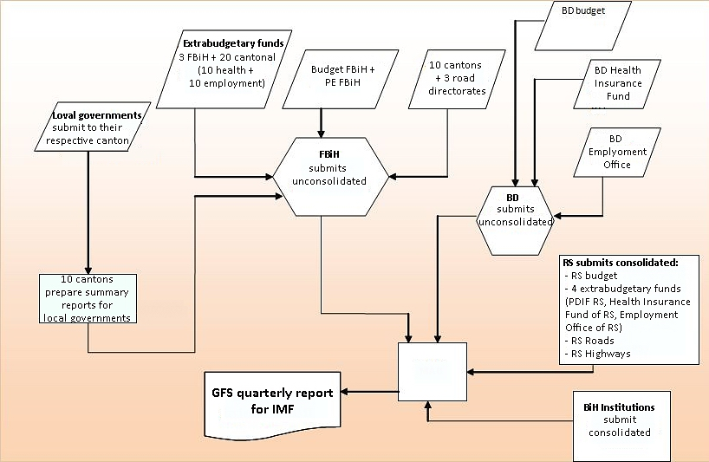
The institutions of BiH, FBiH and BD have submitted non-consolidated summary reports since the beginning, but in the course of 2015 FBiH and BD started delivering consolidated quarterly reports as well. RS delivers only quarterly consolidated reports.

2. Increasing efficiency and effectiveness of budget management

The delay in adopting the 2016-2018 GOF by the Fiscal Council meant that the governments were left with less time to prepare their BFPs. As mentioned earlier, the 2016-2018 GOF was adopted with a delay, but the budgets of the Entities and Institutions of BiH for 2016 were adopted on schedule, while only the Brčko District has not yet adopted the budget for the year 2016.
The 2016-2018 Budget Framework Paper of FBiH was prepared in accordance with the Law on the Budgets of FBiH. It constitutes the preliminary draft budget of FBiH for the year 2016 and contains preliminary budget projections for 2017 and 2018.
The 2016-2018 Budget Framework Paper of RS includes analyses and projections of budgets for all levels of government in RS and extra-budgetary funds.
The 2016-2018 Budget Framework Papers were prepared transparently for the Institutions of BiH and for both Entities and are accessible on the websites of the ministries of finance. Brčko District has not yet started publishing its BFP on its website.
Budget-related legislation for the level of Institutions of BiH and both Entities is harmonised in the part that refers to the process of adopting annual budgets according to the “ten-step” principle. Brčko District is in the process of drafting a new budget law, which is to be harmonised with the laws of the other government levels and adopted by the end of 2016.
Budgets are planned and recorded using a variety of software, ranging from the simplest software to the latest budget management software (BPMIS). The 2016 budgets for the Institutions of BiH and the Entities were planned in the same format in BPMIS. However, this software is not compatible with the treasury software so budget execution is managed within the treasury system.
The Law on the Budgets in FBiH provides for the establishment of the Fiscal Coordination Body of FBiH with the aim of ensuring macroeconomic stability and fiscal accountability of FBiH, and defines its mandate and responsibilities. The Fiscal Coordination Body of FBiH was established in 2015 and meets regularly at the end of every quarter. The entry into force of this Law marked significant progress in strengthening the budget adoption procedures and establishing the fiscal coordination body in FBiH.

2.1 Transparent expenditure of public funds

BPMIS has created conditions for programme-based budgeting at the state and entity levels. Increased transparency in public spending is achieved by ensuring that budgets are planned and budget execution is monitored in accordance with programmes and monitoring indicators.
Submission of budget beneficiaries’ requests according to the Instruction for Budget Beneficiaries No. 1, for the purposes of preparation of the 2016-2018 BFP, was done through BPMIS. Further, Instruction No. 2 and requests for amendments to the budget are also submitted through BPMIS. Entity budgets are planned according to the programme-based budgeting methodology but are not adopted as such and are not published on the websites of the entity ministries of finance.
Since 1 January 2015, the reports by functional classification have been comparable at the level of BiH and entity levels, with the exception of Brčko District as its reports are harmonised using the COFOG methodology. This makes it possible to perform analyses of comparative data by government function at all levels of government.
Budget execution data for 2015 are not available due to the deadlines for the adoption of annual reports. However, even though the report for general government has not yet been released, MAU has published on its website preliminary consolidated report for 2015, which includes: revenues and expenditures of the budget of the Institutions of BiH, revenues and expenditures of the budget of FBiH, revenues and expenditures of the budget of RS, and revenues and expenditures of the budget of BD.
This report does not include revenues and expenditures of the cantonal budgets, cantonal road directorates, municipalities and public funds in FBiH, revenues and expenditures of the road/highway directorates of RS, municipalities and public funds in RS, as well as revenues and expenditures of public funds in BD. Comparison of the data at these levels of government (excluding cantonal and local governments, road directorates at the cantonal and entity levels and extra-budgetary funds) shows that the total expenditure in 2014 was nearly 9% higher than in the preceding year, and nearly 4% lower in 2015 than in 2014 (according to preliminary data for 2015).
Table 1. Distribution of expenditures (excluding cantonal and local governments in BiH) 2013-2015
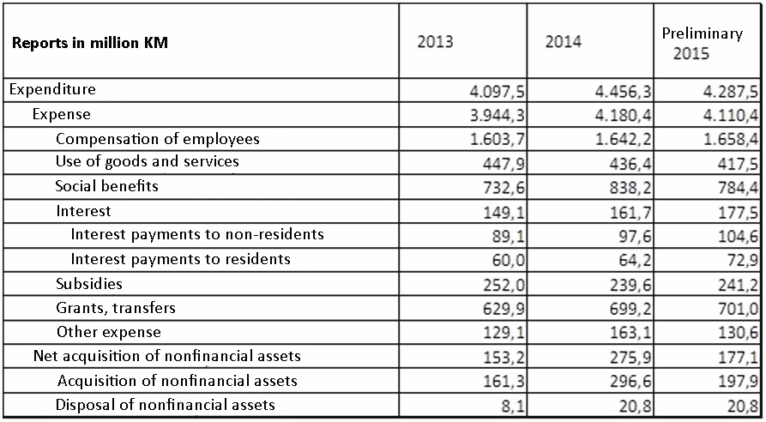
Source: MAU ITA BiH, reports for Stand-by Arrangement BiH and IMF

Although there has been a decline in total expenditures (according to preliminary MAU data) in 2015, the share of gross salaries and employee benefits increased from 37% in 2014 to 39% in 2015, i.e. returned to the same level as it was in 2013.

2.2 Communication between management of institutions and finance units

Communication between management of institutions and finance ministries (sectors, departments, services) should take place on an ongoing basis throughout the budget preparation process.
According to data collected from the institutions included in this survey, a large number of budget beneficiaries (3% more than in 2014) delegate to finance ministries/ departments the task of preparing the budget proposal and monitoring budget execution on their behalf.
The Law on Fiscal Accountability of RS, adopted in 2015, facilitates communication between management and finance units and introduces fiscal rules that constitute permanent or temporary restrictions on fiscal policy in order to further enforce budgetary discipline, improve coordination between different levels of government and establish a fiscal policy that will be sustainable in the long run.
Pursuant to the provisions of the Law on Budgets in FBiH, the Fiscal Coordination Body of FBiH was established in 2015. In addition to its other powers and responsibilities, this Body is tasked with coordinating activities to ensure compliance with budget calendars in respect of budget preparation, adoption, execution and audit.
The Law on Financing the Institutions of BiH provides that the finance officer of each budget beneficiary reports directly to the head of the budget beneficiary and performs such tasks as financial planning, budget preparation and execution of the budget of the given budget beneficiary.

2.3 Introduction of programme-based budgeting in public administration in BiH

Technical requirements for the introduction of programme-based budgeting in the planning phase at all four levels of government have been fulfilled through implementation of BPMIS. Institutions of BiH and the Entities prepared their budgets for 2016 in BPMIS but the budgets are not yet adopted in the programme format. While budgets at entity levels are planned in BPMIS in the programme format, they are still adopted and published only by economic classification in both RS and FBiH.

Staff levels have improved significantly in the last few years, employees receive regular training and continuously improve their knowledge and skills, and a significant number of training sessions have been provided through IPA-funded projects.

With a view to providing additional technical assistance to finance ministries at all four levels of government under the project “Strengthening Public Financial Management”, five pilot budget beneficiaries were selected in the first phase. As a result of the direct technical assistance, they corrected and upgraded the existing programme format and fully implemented the programme-based approach to budgeting.

2.4 Including parliaments in the budget approval process

The Rules on Financial Reporting for Institutions of BiH, which have been in force since 1 January 2015, set forth the format and contents as well as instructions for the preparation of periodic and annual financial reports, periods for which the reports are prepared, as well as methods and deadlines for the preparation of periodic and annual financial reports of institutions of BiH. The Ministry of Finance and Treasury of BiH (MFT BiH) and budget beneficiaries submit periodic and annual financial reports within the time limits specified by these Rules. Budget beneficiaries which have sub-accounts opened within the Single Treasury Account, with regards to earmarked funds and grants, are required to prepare quarterly and annual reports accompanied with a written explanation of how the funds from the sub-account were used and for what purposes. Periodic reports mean the regular quarterly reports submitted by budget beneficiaries to MFT BiH.

In the new Rules, reporting forms have been harmonised with the International Accounting Standards for Financial Reporting and have become part of the Government Finance Statistics (GFS). The Rules introduced a form for reporting on budget expenditures and expenses by government function in accordance with the COFOG methodology (UN’s Classification of the Functions of Government). The form used by all government levels in BiH for reporting to the IMF (“harmonised tables”) was adopted under the name Form 8 – Overview of Revenues, Receipts, Expenditures and Expenses by Economic Categories.
Also, in a separate section of its summary periodic and annual reports, MFT BiH treats of foreign debt servicing, presenting the following information: achieved inflows of funds for foreign debt servicing; completed servicing of liabilities arising from foreign debt shown by creditor and the structure of the liability (principal, interest, and other costs); comparable indicators of planned and executed payments in respect of foreign debt, accompanied with an explanation, and with an indication of any delay in payments; the state of foreign debt as at the end of the reporting period; and the state of the guarantees issued in respect of foreign debt as at the end of the reporting period.
The Rules on Financial Reporting and Annual Budget Calculation in FBiH, which entered into force on 1 January 2015, cut the number of reporting forms with the aim of reducing delays in the submission of reports by budget and extra-budget beneficiaries. The provisions of these Rules apply to the budget of FBiH, cantonal budgets, local government budgets, financial plans of extra-budgetary funds and business plans of public enterprises. The Rules further provide that budget beneficiaries and extra-budgetary funds are required to develop and submit quarterly and annual financial reports, while public enterprises are bound to prepare and submit only quarterly business reports. The Rules introduced a form for reporting on budget expenditures and expenses by government function in accordance with the COFOG methodology as well as the IMF reporting form (“harmonised tables”) called Overview of Revenues, Receipts, Expenditures and Expenses by Economic Categories.
The Rules on Financial Reporting for Beneficiaries of the Budgets of the Republic, Municipalities, Cities and Extra-budgetary Funds of RS, which has been in force since 2011, set forth the format and contents as well as methods of preparation and presentation of financial reports for budget beneficiaries of the Republic, municipalities, cities and funds. The financial reports include: monthly, quarterly and annual financial reports of individual budget beneficiaries and annual financial reports for certain levels of government. The Rules introduced a form for reporting on budget expenditures and expenses by government function in line with the COFOG methodology.
The 2007 Rules on Financial Reporting and Annual Budget Calculation of BD define the content, financial reporting methods and instructions for the preparation of periodic, annual and additional financial reports on budget execution. The Rules do not provide for a form for reporting on budget expenditures and expenses by government function in line with the COFOG methodology.
To conclude, all levels of government, except BD, prepare comparable reports on budget expenditures and expenses by government function in accordance with the COFOG methodology.
RS and BD use a harmonised chart that is aligned with GFS (prepared by the IMF) for the purposes of quarterly and annual reporting under SBAs, but this form has not been adopted as an integral part of their Rules on Financial Reporting.
As noted earlier, the reporting forms are continuously improved and upgraded, but monitoring the effects of measures and cost-effectiveness of individual programmes will not be possible until such time as programme-based budgeting is introduced in full.

2.5 Inclusion of extra-budgetary funds in the medium-term expenditure framework and budget process

The Law on the Budget System of RS, adopted in December 2012, provides that the budget system of RS consists of the budget of the Republic, the budgets of local governments and the budgets of extra-budgetary funds. As at 1 January 2016, all extra-budgetary funds were outside the Treasury System and prepared their own financial plans. The amendments to the Law on the Budget System of RS adopted in December 2015 provide that the 2016 financial plan of the Pension and Disability Insurance Fund of RS (PDIF RS) shall be an integral part of the RS budget for the year 2016.
Although PDIF RS is included in the Treasury System of RS and has become an integral part of the RS budget for the year 2016, Article 66 b of the Law Amending the Law on the Budget System of RS (“Official Gazette of RS”, No. 103/15) provides that “In preparing the budget of the Republika Srpska for 2016, Articles 21, 22, 23 and 25 of this Law, which govern the preparation of the budget of the Republic, shall not apply to the Pension and Disability Insurance Fund of the Republika Srpska”. More specifically, provisions governing the budget calendar and “ten-step” budgeting process do not apply as it would be impossible to synchronise the necessary activities for the year 2016.
The Government of RS prepares the BFP and includes projections for local governments and extra-budgetary funds. Local governments in RS do not prepare their own BFPs, unlike FBiH; instead, they consult with the Ministry of Finance of RS during the preparation of their annual budgets about ceilings for projected revenues and the structure of budgetary spending.
The 2016-2018 BFP of FBiH includes revenue projections for: the budget of FBiH, the budgets of cantons and local governments, the budgets of extra-budgetary funds (primarily the Pension and Disability Insurance Fund, the Health Insurance Fund and the Employment Office) and the funds of public enterprises that are collected as public revenues from special fees prescribed by law. Some extra-budgetary funds and beneficiaries at the cantonal level of government are included in the treasury system, for example: cantonal employment offices and road directorates are included in the treasury system in seven cantons, and remain out of the system only in the Una-Sana, Central Bosnia and Tuzla cantons.
When planning a budget for a fiscal year, all levels of government include known and certain grants. Grants received after the adoption of the budget are recorded in accounting records and are subject to financial reporting in accordance with the applicable legal regulations.

3. Improving the accounting framework and the treasury system operations

As noted in the first monitoring report done for the year 2014, RS began to implement accrual accounting on 1 January 2013; however, budget execution reports and the IMF reporting form are prepared on a modified accrual basis.
All other levels of government in BiH record transactions following a modified principle.
All budget beneficiaries in RS, except for the newly formed local self-government Stanari, are included in the Single Treasury Account. None of the extra-budget beneficiaries were included in the treasury system as at 31 December 2015. However, pursuant to the latest amendments to the Law on the Budget System of RS and the Law on Pension and Disability Insurance, PDIF RS became part of the treasury system on 1 January 2016, meaning that on 1 January 2016 the revenues and receipts, and expenditures and expenses of PDIF RS became part of the RS budget.
By law, local governments in FBiH were obliged to introduce the Treasury system of operations by 2011; however, the system has not been fully implemented yet. Federal and cantonal levels of government have introduced the treasury system of operations. Some extra-budgetary beneficiaries at the cantonal level are included in the treasury system, e.g. road directorates in seven cantons. In Sarajevo Canton, all nine local governments have introduced the treasury system operations. Some cantons do not have information on how many of their local governments have or have not introduced the treasury system operations to date. None of the cantons and their local governments have established a link between the two treasury systems.
Treasury software for BiH, FBiH, RS and cantonal governments was procured from grants, while for local governments treasury software was provided by various donor projects or its purchase was financed from local governments’ own budgetary resources. For the full introduction of treasury operations in the public administration in BiH, it would be necessary to seek donor support.

4. Introduction of PIFC in full compliance with EU requirements

As noted in the first monitoring report for 2014, with the aim of harmonising their PIFC legislation and practices with those in the EU, all government levels in the country implemented relevant activities ranging from the adoption of legislation, to the establishment of new organisational units within the finance ministries, to the adoption of implementing regulations and the training of staff.
Development of the PIFC system at the level of BiH is the responsibility of the Central Harmonisation Unit (CHU), in accordance with the Law on Internal Audit of the Institutions of BiH and the Law on Financing the Institutions of BiH. CHU was established within the MFT BiH and has, to date, published on MFT BiH’s website the annual consolidated reports on internal audit for 2011, 2012, 2013 and 2014 and the Annual Report on the Introduction of the Financial Management and Control System in the Institutions of BiH for 2014.
FBiH Ministry of Finance (FM FBiH) formed its CHU as a body responsible for coordinating the development of methodology and work standards for financial management and control, internal audits, organising training and checking the quality of the internal financial controls system.
In accordance with the Law on Internal Audit, CHU has to date prepared four annual consolidated reports (for 2011, 2012, 2013 and 2014) on the state of internal audit, which the FM FBiH submitted to the Government of FBiH. In practice, however, internal audit function has not yet been established in all institutions, or if it has, it is not always fully compliant with applicable regulations in terms of its location in the organisational structure and the description of its tasks.
RS has formed the CHU that proposes legislation in the field of financial management and control (FMC) and internal audit (IA), and oversees the implementation of adopted legislation. The Law provides that the RS CHU is responsible for preparing consolidated annual reports on the financial management and internal control system in public sector institutions and annual reports on internal audit function in the public sector of RS. However, transparency of RS CHU’s work leaves much to be desired as the only report available on its website is the consolidated report on internal financial control for 2011.
The Audit Office for Public Administration and Institutions in the Brčko District of BiH was established in 2007 and operates in accordance with the Law on Audit of Public Administration and Institutions in the Brčko District of BiH (“Official Gazette of the Brčko District of BiH”, No. 40/08). BD Government adopted the 2014-2017 Strategy for Development of Public Internal Financial Control (PIFC) with the aim of establishing the internal control function. The Office prepares annual audit plans which are adopted by the Assembly of the Brčko District of BiH. No report on the Office’s work is available on the website of BD, which makes the work of this Office opaque.

5. Improving the organisational structure and investing in capacity-building

Ministries of finance adopt their respective staffing/recruitment plans as well as training plans in accordance with their priorities and available financial resources.
The Budget Department of MFT BiH planned systematically and its current staffing levels are therefore satisfactory. Also, its staff have received several training sessions to date. Since the Budget Department has enough personnel to carry out reforms, investments will be made in the coming period to strengthen and develop their personal skills and knowledge. The Sector agrees internally on the annual recruitment plan and training plan for the current year.
The Rules on Internal Organisation and Staffing in the Ministry of Finance of RS provide for a sufficient number of public sector analysts in the Budget and Public Finance Department, as well as staff in other departments of the ministry.

The FBiH Ministry of Finance remains below the envisaged staffing levels due to the restrictive employment policy, in particular when it comes to the budget department. Also, one of the problems is the lack of suitably qualified personnel in the field of internal control and audit given the complex administrative structure of FBiH and the large number of institutions that are under obligation to establish the IA function. CHU is working on an ongoing basis to provide training to internal audit staff.

6. Improvement of public debt management efficiency

During the 1980s and 1990s most OECD economies experienced a rapid growth in public debt. Introducing fiscal discipline for policymakers of these countries required the establishment of new fiscal rules and discipline. To that end ceilings were imposed at the EU level on deficit and debt as well as medium-term budget targets.
BiH has a highly decentralised fiscal system and it was necessary to introduce fiscal discipline. The establishment of the Fiscal Council of BiH was the first attempt to harmonise methodologies and ensure macroeconomic stability and fiscal sustainability of BiH, FBiH, RS and BD.
According to the Central Bank of BiH (CBBH), the share of the foreign debt of the government sector in GDP in 2005-2014 varied from 18% to 30%.
The National Economic Reform Programme (NERP) for the period 2015-2017, which BiH prepares and submits to the EU based on the data collected from all government levels in BiH, presents the share of public debt (the sum of foreign and domestic debts) in GDP in the amount of 36.9%, 35%, 32.1%, and finally, in 2017, 27.8% (Table 2).

Table 2. Status of public debt and projections (in million KM)
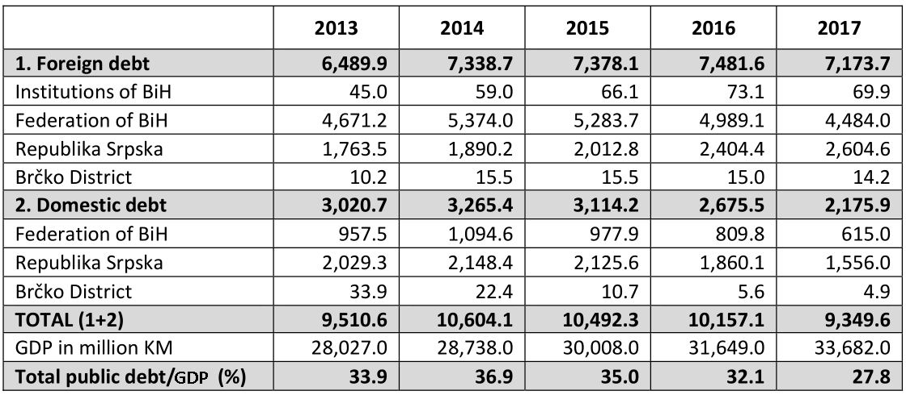
Source: National Economic Reform Programme of BiH 2015-2017

However, a year later, the Economic Reform Programme for 2016-2018, which the governments in BiH prepared and submitted to the EU, showed that the share of the public debt in BiH was more than 5% higher annually than had been projected by NERP.

Table 3. State of public debt and projections (in million KM)
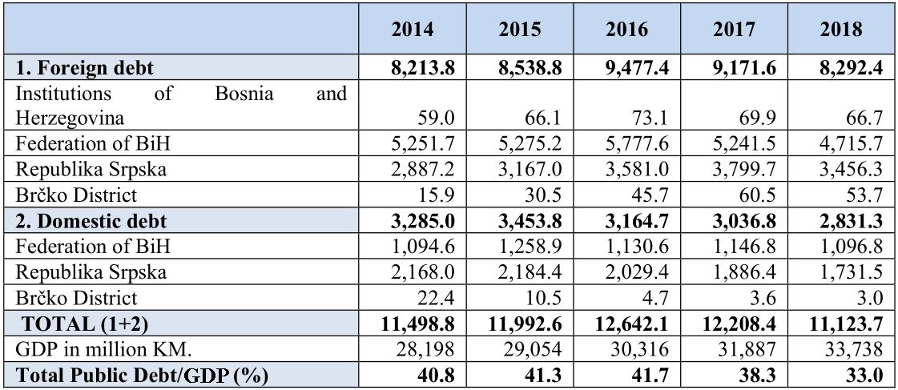Source: Economic Reform Program of BiH 2016-2018

Comparison of the data for the 2014-2017 period reveals large differences in the projections, which may be due to either unrealistic projections or unharmonised public debt monitoring methodologies.

Figure 2. Share of Public Debt in GDP
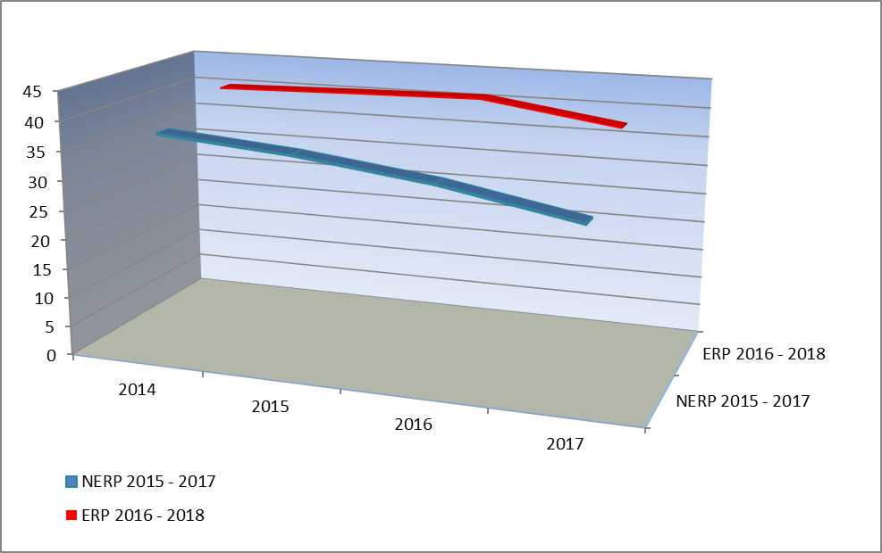
Data Sources: NERP 2015-2017, ERP 2016-2018
Such a high level of debt in a country that faces a series of reforms aimed at ensuring a more competitive, stable and sustainable economy, as well higher employment and integration in the EU, requires that more effort be put in to ensure more efficient management of public debt.
All levels of government need to give their consent and put in more effort to adopt a single methodology for monitoring and reporting on debt and guarantees. The adoption of single reporting methodology and harmonised tables will contribute significantly to efficient public debt management. Harmonisation of debt reporting would have an impact on Objective No. 1 defined under RAP1, which concerns the policy dimension of the public finance system, particularly as regards the regular preparation of the macro-fiscal framework for BiH (i.e. GOF), which currently has shortcomings in the part relating to debt and borrowing projections.
FBiH developed and, in the course of 2015, adopted the Debt Management Strategy 2016-2018. The Strategy highlights the activities that will be undertaken to facilitate its implementation, including the enhancement and improvement of communication with market participants, as well as documents and key information related to debt and borrowing, which will be published on the website of the FBiH Ministry of Finance. The disclosure of these documents and their general accessibility is a key factor in ensuring transparency of public debt management and further improvement of communication with creditors and investors in FBiH securities. In order to ensure consistency with government policies, the Strategy will be reviewed and updated every year, as part of the budget process, and, if necessary, more frequently in the event of significant changes in the market.
MFT BiH is drawing up, in cooperation with the World Bank, a debt management strategy for the level of BiH. Further, other levels of government are recommended to accelerate the adoption of their own debt management strategies. For the purposes of public debt management in BiH, software was purchased to analyse and monitor the country’s public indebtedness. The software was installed in the MFT BiH and accepted in the test environment, and additional equipment (hardware) was purchased.

The personnel working on public debt management at all levels of government participated in training sessions organised by the World Bank in 2015.

III Recommendations for achieving PAR objectives in the area of public finance

What continues to pose a challenge in the implementation of public finance reform is the high level of public debt, constant growth of foreign debt from 2008 to 2016, continued strong reliance on donor funds, underdeveloped capacities for internal audit, financial management and internal control, and lack of fiscal discipline.
Recommendations for further reform in the area of ​​public finance were formulated on the basis of the monitoring and presented by individual chapters and reform objectives.
1. Policy dimension of the public finance system
Recommendation: Indicators of all objectives and activities set out in this section were marked as “achieved” in the reports of the Public Administration Reform Coordinator’s Office (PARCO). However, the quality of the output documents that are the result of these objectives is not satisfactory and, from the standpoint of quality, these objectives have not been fully achieved. This is due to the fact that RAP1 indicators are made up mostly of process indicators rather than performance indicators. When preparing a new strategic framework for the reform of public finance and the monitoring system, it is recommended to abandon the practice of monitoring process indicators as well as establish a results-oriented monitoring system, while placing an emphasis on the quality of improvements, rather than only recording whether the changes occurred.
Rationale: One of the objectives achieved under this chapter is the regular development of the macro-fiscal framework for whole BiH through the Global Framework of the Fiscal Balance and Policy in BiH (GOF). GOF has been adopted, but there remains the question of timeliness and quality of the adopted document. It has become a common practice for GOF to be adopted with delays, and the quality of the document is unsatisfactory, especially in the part that concerns the borrowing ceiling as only indicative projections for the next fiscal year are shown, without projections for a three-year period. On 17 June 2014 the Fiscal Council adopted GOF for the period 2015-2017, and on 23 June 2015 GOF for the period 2016-2018. This means that there was a violation of provisions defined in the Rules of Procedure of the Fiscal Council, which set 31 May of each year as the deadline for the adoption of GOF or the revised GOF. Delays in the adoption of GOF cause further delays in preparation and adoption of the Budget Framework Papers (BFPs) i.e. budgets for all levels of government in BiH, in contravention of the deadlines set in the budget calendars of the Law on Financing the Institutions of BiH, the Law on Budgets in FBiH, the Law on the Budget System of RS, and the Budget Law of BD.

2. Increasing efficiency and effectiveness of budget management
Recommendation 1: Communication between management of institutions and finance units has only partially improved in practice. It is recommended to ensure continued cooperation, communication and control of spending throughout the fiscal year.
Rationale: Most institutions have appointed persons responsible for cooperation with the finance units in the budget planning and execution process; however, only 24% of the surveyed institutions submitted (largely incomplete) information about their planned and actual expenditure, outstanding liabilities, etc. This indicates that budgets are still planned in the finance units without continued involvement of the institutions and their representatives in the budget planning and monitoring of budget execution. The finance units are most frequently contacted regarding the signing of the statement of fiscal accountability of managers of budget beneficiaries pursuant to the provisions of the Law on Fiscal Accountability of RS adopted in 2015, the Law on Financing the Institutions of BiH and the Law on Budgets in FBiH.
Recommendation 2: The objective of ensuring full introduction of programme-based budgeting in public administration in BiH has not been achieved, only technical preconditions have been created for it. All levels of government need to make further efforts towards reaching this objective, which will be attained once budgets start to be adopted and made publicly accessible in the programme format.
Rationale: The introduction of multi-annual planning of public funds with the help of the Budget Planning and Management Information System (BPMIS) for the levels of BiH, FBiH and RS was marked as “achieved objective” in terms of purchasing and installing the software. In 2015 BFPs and budgets for the year 2016 were prepared in BPMIS; however, they are still not adopted according to programme classification, but rather according to economic and organisational classification. This objective will be considered attained once budgets start to be adopted by parliaments in the programme format and made publicly accessible in the programme, economic and organisational formats.
Recommendation 3: Timely inclusion of parliaments in the budgeting process as well as expanded reporting to parliaments and the public in BiH remains unsatisfactory. In order to ensure inclusion of parliaments and the public in budgeting and reporting processes, it is necessary to continuously improve the reporting process and introduce mandatory preparation and dissemination of “citizens budgets”.
Rationale: Citizens are typically, but not sufficiently, included in the budgeting process through the NGO sector in line with the budget calendar. Budgets and budget execution reports are not prepared in a citizen-friendly format that is easier to understand than the one prepared for the purposes of parliaments. In 2015 several local communities (Bijeljina, Tuzla, Zenica) prepared their budgets in the citizen-friendly format (so called “Citizens Budget”) and made them available on their websites. Also, 2015 saw the launching of the “Civil Society Sustainability Project”, which calls for amendments to the Law on Budgets in FBiH, Law on the Budget System of RS and the Budget Law of BD providing for the introduction of the Citizens Budget as a mandatory document in the budget cycle. The introduction of mandatory preparation of the Citizens Budget will help ensure that the public is included in the budgeting process and reporting in a timely manner.
Financial reporting to governments and parliaments has improved in 2015 upon the entry into force of the Rules on Financial Reporting of Institutions of BiH and the Rules on Financial Reporting and Annual Budget Calculation in FBiH. In FBiH the number of reporting forms has been cut with the aim of reducing delays in the submission of reports by budget and extra-budget beneficiaries, while the Institutions of BiH retained the same number of forms as in 2014.

3. Improving the accounting framework and the treasury system operations
Recommendation 1: The International Public Sector Accounting Standards (IPSAS) have not been introduced at all levels of government. A coordinating body which would be composed of representatives of the finance units (FBiH, BiH Institutions and BD) and tasked with identifying the capacity for the introduction of IPSAS and accrual accounting has not been formed yet. FBiH, BiH Institutions and BD should coordinate to seek donor support for the introduction of IPSAS and accrual accounting.
Rationale: By adopting the International Public Sector Accounting Standard (IPSAS) 23 – Revenue from Non-Exchange Transactions (Taxes and Transfers), RS began to implement accrual accounting on 1 January 2013 and has since recognised revenues on an accrual basis in the financial reports defined under the Rules on Financial Reporting for Beneficiaries of the Budgets of the Republic, Municipalities, Cities and Extra-budgetary Funds.
For the purposes of reporting on budget execution, RS applies a modified accrual basis. All other government levels in BiH record transactions following a modified principle whereby revenues are recorded in the period in which they become available and measurable (on a cash basis) and expenditures are recognised the moment a liability arises, regardless of when the payment is made (on an accrual basis). Accordingly, all financial reports are prepared following the modified principle.
Recommendation 2: The objective of introducing the treasury operations in the entire public administration in BiH has not been achieved. It is recommended that donor support be sought in order to implement this objective in FBiH.
Rationale: Introduction of Treasury operations in the entire public administration is an activity that continues to demand considerable efforts and funds in FBiH. All municipalities in RS, except for the newly formed municipality Stanari, are included in the treasury system of RS. The Pension and Disability Insurance Fund of RS became part of the treasury system, too, on 1 January 2016. By law, local governments in FBiH were obliged to introduce the Treasury system of operations by 2011; however, the system has not been fully implemented yet. Federal and cantonal levels of government have introduced the treasury system of operations with the help of donor support. Some extra-budgetary beneficiaries at the cantonal level are included in the treasury system, e.g. cantonal road directorates are included in the treasury system in seven cantons, and remain out of the system only in the Una-Sana, Central Bosnia and Tuzla cantons. None of the cantons and their local governments have established a link between these two treasury systems.

4. Introduction of PIFC in full compliance with EU requirements
Recommendation: The objective of introducing PIFC in full compliance with the relevant EU requirements has not been reached within the timeframe defined under the Strategy. Albeit mandatory, annual reports on internal audit and financial management are not prepared and disclosed by all Central Harmonisation Units (CHUs). Coordinating committees of CHUs need to begin meeting again on a regular basis and get engaged in the implementation of the PIFC strategy. All levels of government need to continue to work on a comprehensive development of PIFC because, along with ensuring legality and compliance in the expenditure of funds, it is also essential to achieve prudence, efficiency and effectiveness in the management of public budgetary resources.
Rationale: Improvements achieved in 2015 include: at the level of BiH – adoption of Guidelines for the Implementation of Risk Management in BiH Institutions, which constitute one of the bases for the establishment and efficient operation of financial management and control in the institutions of BiH; at the level of FBiH – starting a public debate on the Draft Law Amending the Law on Internal Audit in the Public Sector in FBiH in October 2015; at the level of RS – adoption of the new Law on Accounting and Auditing of RS, October 2015.
As regards training of employees at all levels of government, 170 internal auditors and 17 trainers received training under the “Strengthening Public Expenditure Management” project, and 130 employees and 4 trainers received training in financial management and control.

- Improving the organisational structure and investing in capacity- building
Recommendation: It is necessary to make plans, systematically and on a continuing basis, for capacity-building in the ministries of finance, as well as the number of training sessions and number of participants.
Rationale: Significant progress has been made in improving the organisational structure and investing in capacity-building in the ministries of finance at all levels of government. Notwithstanding the policy of limiting further employment in public administration, it is necessary to ensure that there are enough IT experts and specialists in the field of internal audit.

6. Improvement of public debt management efficiency
Recommendation: Progress in enhancing public debt management efficiency has not been achieved as planned under RAP1. All levels of government need to reach agreement on the adoption of a single public debt management methodology and ensure better coordination.
Rationale: It is evident that BiH is faced with a consolidated budget deficit and mounting public debt. Therefore, it is necessary to ensure fiscal consolidation, which will gradually lead to a reduction of the budget deficit as well as a medium-term reduction in public debt levels. Increasing public debt management efficiency is also emphasised in Reform Agenda of BiH 2015-2018. It is recommended to adopt single methodology and reporting tables, as it would contribute significantly to efficient public debt management and have a positive impact on this reform objective. Harmonisation of reporting on debt would have an impact on the quality of results that follow the policy dimensions of public finance system which is currently deficient in the part that relates to debt and borrowing projections.

IV Annexes

Annex 1
Public Finance
State level (BiH)
- Ministry of Justice
- Civil Service Agency
- Public Administration Reform Coordinator’s Office (PARCO)
- Ministry of Foreign Affairs
- Directorate for European Integration
- Ministry of Defence
- Ministry of Civil Affairs
- Ministry of Finance
- The Ministry for Refugees and Displaced Persons
- Communication Regulatory Agency for
- Central Harmonisation Unit (Ministry of Finance and Treasury of BiH)
- Directorate for Coordination of Police Bodies of BiH (Ministry of Security of BiH)
- Market Surveillance Agency of BiH
- Agency for Development of Higher Education and Quality Assurance of BiH
- Agency for Prevention of Corruption and Coordination of the Fight against Corruption (APIK)
Federation of BiH
- Ministry of Justice of FBiH
- Ministry of Finance of FBiH
- Ministry of Education of FBiH
- Civil Service Agency of FBiH
- Tax Administration of FBiH
- Ministry of Agriculture, Water Management and Forestry of FBiH
- Ministry of Displaced Persons and Refugees of FBiH
- Ministry of Health of FBiH
- Ministry of Physical Planning of FBiH
- Banking Agency of FBiH
- Agency for Privatisation in FBiH
- Directorate for Commodity Reserves of FBiH
- Administration for Geodetic and Real Property Affairs of FBiH
- Securities Commission of FBiH
- Public Health Institute of FBiH
RS
- Civil Service Agency of RS
- Ministry of Public Administration and Local Self-government of RS
- Ministry of Finance of RS
- Ministry of Labour, War Veterans and Disabled Persons’ Protection of RS
- Helicopter Service of RS
- Ministry of Agriculture, Forestry and Water Management of RS
- Ministry of Health and Social Welfare of RS
- Ministry for Refugees and Displaced Persons of RS
- Ministry of Justice of RS
- Ministry of Spatial Planning, Civil Engineering and Ecology of RS
- Ministry of Family, Youth and Sports of RS
- Banking Agency of RS
- Administration for Geodetic and Real Property Affairs of RS
- Administration for Inspection Affairs of RS
- Agency for Development of Small and Medium Enterprises of RS
Brčko District
Subdivision for Human Resources

Annex 2
BiH
- Law on Indirect Taxation System in BiH (“Official Gazette of BiH”, Nos. 44/03, 52/04, 34/07, 4/08, 49/09 and 32/13)
- Law on Payments into the Single Account and Distribution of Revenues (“Official Gazette of BiH”, Nos. 55/04, 34/07 and 49/09)
- Law on Financing the Institutions of BiH (“Official Gazette of BiH”, Nos. 61/04, 49/09)
- Law on the Council of Ministers of BiH (“Official Gazette of BiH”, Nos. 30/03, 42/03, 81/06, 76/07, 81/07, 94/07 and 24/08)
- Rules on Accounting along with the Accounting Policies and Procedures for the Beneficiaries of the Budget of Institutions of Bosnia and Herzegovina http://www.mft.gov.ba/hrv/images/stories/pravilnici/Pravilnik_o_racunovodstvuBiH_hrv.pdf

Brčko District
- Budget Law of the Brčko District of BiH (“Official Gazette of the Brčko District of BiH”, No. 34/08);
- Treasury Law of the Brčko District of BiH (“Official Gazette of the Brčko District of BiH”, Nos. 03/07, 19/07, 02/08);
- Law on Accounting and Auditing of the Brčko District of BiH (“Official Gazette of the Brčko District of BiH”, Nos. 06/06, 19/07);
- Decree on Budget Accounting of the Brčko District of BiH (“Official Gazette of the Brčko District of BiH”, No. 25/07);
- Rules on Budget Reporting and Annual Budget Calculation of the Brčko District of BiH (“Official Gazette of the Brčko District of BiH”)
- Decision on Accounting Policy for the Budget Beneficiaries and the Treasury of the Brčko District of BiH (“Official Gazette of the Brčko District of BiH”)

Federation of BiH
- Law on Budgets in the Federation of BiH (“Official Gazette of FBiH”, Nos. 102/13, 9/14,13/14 and 8/15)
- Law on Allocation of Public Revenues of FBiH (“Official Gazette of FBiH”, Nos. 22/06, 43/08, 22/09, 35/14 and 98/15)
- Law on Accounting and Auditing in FBiH (“Official Gazette of BiH”, No. 83/09)
- Rules on Financial Reporting and Annual Budget Calculation in FBiH (“Official Gazette of FBiH”, No. 69/14)
- Law on Treasury in FBiH (“Official Gazette of FBiH”, Nos. 58/02, 19/03, 79/07)
- Accounting Policies for the Budget Beneficiaries and the Treasury of the Federation of BiH (“Official Gazette of FBiH”, No. 9/11)
- Rules on Budget Accounting in FBiH
- Rules on Financial Reporting and Annual Budget Calculation in FBiH (“Official Gazette of FBiH”, Nos. 69/14, 14/15)
- Rules on the Payment of Public Revenues of the Budget and Extra-budgetary Funds in the Territory of FBiH (“Official Gazette of FBiH”, Nos. 3/11, 6/11, 9/11,18/11,39/11, 64/11i 87/11 , 5/12, 41/12, 69/12, 93/12, 101/12 and 105/12)

Republika Srpska
- Fiscal Accountability Law of RS (“Official Gazette of RS”, No. 94/15)
- Law on the Budget System of RS (“Official Gazette of RS”, Nos. 121/12, 52/14 and 103/15);
- Law on Budget Execution for Fiscal Year of RS (“Official Gazette of RS”, Nos. 128/06, 116/12);
- Law on Accounting and Auditing of RS (“Official Gazette of RS”, No. 36/09) – consolidated version (“Official Gazette of RS”, No. 52/11);
- Order on Budget Classification, Account Contents and Use of the Chart of Accounts for Users of Public Revenues, Municipalities, Cities and Funds (“Official Gazette of RS”, No. 90/10);
- Rules on Budget Classification, Account Contents and Use of the Chart of Accounts for Beneficiaries of the Budget of the Republic, Municipalities, Cities and Funds (“Official Gazette of RS” No. 90/10)
- Rules on Accounting, Accounting Policies and Accounting Estimates for the Budget Beneficiaries in RS (“Official Gazette of RS”, No. 127/11);

Fiscal Coordination
- Law on Fiscal Council in Bosnia and Herzegovina (“Official Gazette of BiH”, No. 63/08)
- Rules of Procedure of the Fiscal Council
- Global Framework of the Fiscal Balance and Policy in BiH 2016-2018 http://www.mft.gov.ba/bos/images/stories/budzet/2015/Globalni%20okvir%20fiskalnog%20bilansa%20i%20politika%20u%20BiH%202016-2018-BOS.pdf
- https://www.imf.org/external/pubs/ft/gfs/manual/gfsfs.pdf

The list of institutions is provided in Annex 2.
http://www.oma.uino.gov.ba/09_izvjestaji.asp?l=b
The Public Administration Reform Fund of BiH funded the procurement of the BPMIS software “Budget Planning and Management Information System”
http://unstats.un.org/unsd/cr/registry/regcst.asp?Cl=4 http://unstats.un.org/unsd/cr/registry/regcst.asp?Cl=4
Also includes extra-budgetary funds recorded in the General Ledger of the Treasury of RS, total foreign debt for the projects implemented through local governments and enterprises, as well as data on RS budget beneficiaries that have their own bank accounts (including the units for implementation of foreign projects established within ministries). Data for December are partly estimated.
http://www.oma.uino.gov.ba/09_izvjestaji.asp?l=b
http://www.vladars.net/sr-SP-Cyrl/Vlada/Ministarstva/mf/Documents/%D0%91%D1%83%D1%9F%D0%B5%D1%82%20%D0%A0 % D0% B5% D0% BF% D1% 83% D0% B1% D0% BB% D0% B8% D0% BA% D0% B5% 20% D0% A1% D1% 80% D0% BF% D1% 81 % D0% BA% D0% B5% 20% D0% B7% D0% B0% 202016th% 20% D0% B3% D0% BE% D0% B4% D0% B8% D0% BD% D1% 83_498890977.pdf
http://www.fmf.gov.ba/v2/userfiles/userfiles/file/budzet2016/Prihodi%20-%20bos.pdf
http://unstats.un.org/unsd/cr/registry/regcst.asp?Cl=4
Public Internal Financial Control
http://www.mft.gov.ba/bos/index.php?option=com_content&view=article&id=706&Itemid=100034
http://www.mft.gov.ba/bos/index.php?option=com_content&view=article&id=707&Itemid=100035
http://www.vladars.net/sr-SP-Cyrl/Vlada/Ministarstva/mf/OM/harmonisacija/Pages/default.aspx#collapsible0
http://www.fmf.gov.ba/v2/userfiles/userfiles/file/Strategija%20upravljanja%20dugom%202016-2018_.pdf

